 | 14.1.10 Editors - Video Sequence Editor - Header - Image Menu
Table of content
Image menu 1
Clear 1
Position 1
Scale 1
Rotation 1
All Transforms 1
Apply 1
Scale to Fit 1
Scale to Fill 1
Stretch to Fill 2

Image menu
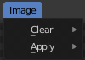
The Image menu contains strip related functionality. The images of the strips can be transformed in the preview window.

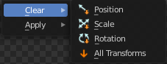
Clear

Position
Resets the position of the image.

Scale
Resets the scale of the image.

Rotation
Resets the rotation of the image.

All Transforms
Resets all transformations of the image.

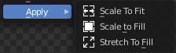
Apply
Apply does NOT apply, it scales the images in various ways.

Scale to Fit
Scales the image to fit in the preview window in at least one direction.

Scale to Fill
Scales the image so that the whole preview window is covered.

Stretch to Fill
Stretches the image so that the whole preview window is covered.

